CLIMATE :
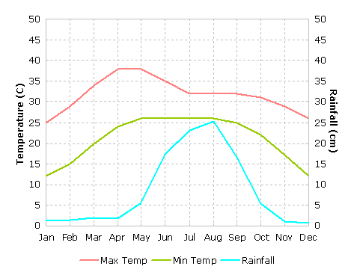
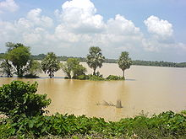
West Bengal's climate varies from tropical savannah in the southern portions to humid subtropical in the north. The main seasons are summer, rainy season, a short autumn, and winter. While the summer in the delta region is noted for excessive humidity, the western highlands experience a dry summer like northern India, with the highest day temperature ranging from 38 °C (100 °F) to 45 °C (113 °F). At nights, a cool southerly breeze carries moisture from the Bay of Bengal. In early summer brief squalls and thunderstorms known as Kalbaisakhi, or Nor'westers, often occur. Troughs of low pressure are often developed near the Bay of Bengal, resulting cyclonic storms. These are known as Ashwiner Jhar and often cause huge destruction. This season is a festive season in West Bengal due to celebration of Durga puja, Lakshmi puja and Diwali. Monsoons bring rain to the whole state from June to September. Heavy rainfall of above 250cm is observed in the Darjeeling, Jalpaiguri and Cooch Behar district. Later, blowing westwards, the winds cause average rainfall of 125 cm in the northern plains and western plateau region. During the arrival of the monsoons, low pressure in the Bay of Bengal region often leads to the occurrence of storms in the coastal areas. West Bengal receives the Bay of Bengal branch of the Indian Ocean monsoon that moves in a northwest direction. Winter (December–January) is mild over the plains with average minimum temperatures of 15 °C (59 °F). A cold and dry northern wind blows in the winter, substantially lowering the humidity level. However, the Darjeeling Himalayan Hill region experiences a harsh winter, with occasional snowfall at places.

